**2 Project Specification**

**2.1 User Requirements**

There are FIVE types of users divided by front-end and back-end. For the front-end, users are visitors and customers. For the back-end, the users are administrators, salespersons, and the shipper.

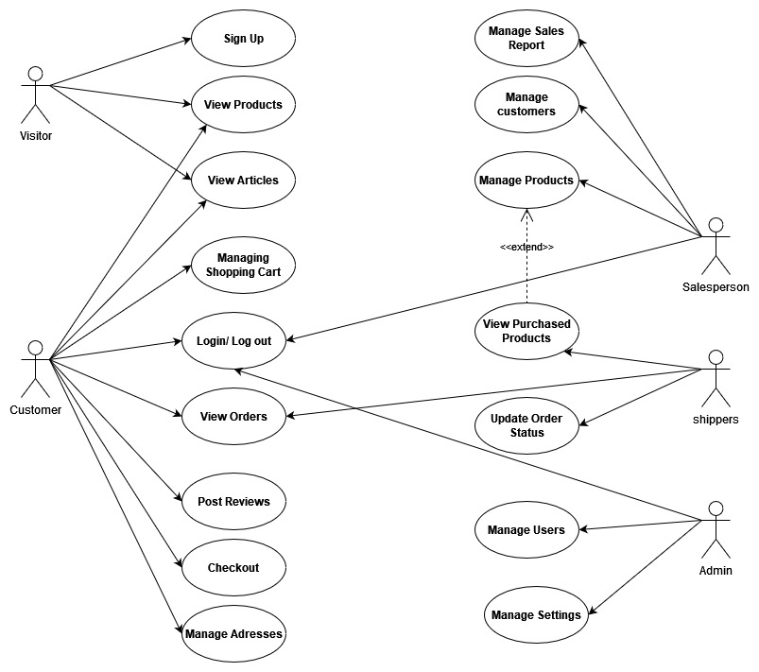

[USE CASE DIAGRAM]

**2.2 System Requirements**

**2.2.1 Functional Requirements**

1. The system MUST retain information of every user including their:

|  |  |  |
| --- | --- | --- |
| * First and last name | * phone number | * Email |
| * Gender | * Addresses |  |

2. The system MUST retain information of products:

|  |  |  |
| --- | --- | --- |
| * Brands | * Brands ID | * Brand Logo |
| * Product Categories | * Product Images | * Prices |

3. The system MUST retain information of orders:

|  |  |  |
| --- | --- | --- |
| * Order ID | * Product ID | * Quantities |
| * Prices | * Shipping Cost | * Order Status |
| * Order Time | * Deliver Date | * Payment Method |

4. The users CAN modify their personal information.

5. The system MUST alert when users input data in illegal format.

6. The system MUST give different types of users different

7. The system MUST display the total value of the selected items and shipping costs separately.

8. The visitors and customers MUST be able to view the categories on the home page.

9. The visitors and customers MUST be able to view items in different categories.

10. The customer SHALL be able to view information about an item before adding it to the cart.

11. The visitor MUST be able to register as a customer.

12. The customer MUST be able add items to the cart.

13. The customer MUST be able to able view the shopping cart.

14. The customer MUST be able to check out with the current items in the cart.

15. The customer SHALL be able to check out items if there are items in the shopping cart.

16. The customer MUST login using the authentication form, and verification code.

17. The customer SHOULD not login or register if the information is incomplete or invalid

18. The customer MUST place an order by completing the information in the order form.

19. The administrator MUST be able to view all the customers and salespersons’ information.

20. The administrator MUST be able to add new items to the list of shopping items.

21. The administrator MUST be able to modify or update an item’s price and description.

22. The administrator MUST be able to delete items from the shopping-cart.

23.The salespersons SHALL be able to view all the users’ information that completes the order form and the checkout process.

24.The salespersons MUST be able to add new items to the list of shopping items.

25. The salespersons MUST be able to modify or update an item’s price and description.

26. The salespersons MUST be able to delete items from the main page of the shopping-cart.

27. The shipper MUST be able to view orders.

28. The shipper MUST be able to search orders.

29.The shipper MUST be able to update orders’ status (picked, shipping or delivered)

**2.2.2 Non-Functional Requirements**

1. Administrators and users CAN access the application all year round any time, 24/7.

2. The website MUST be accessible from any devices connected to the Internet such as personal computer, laptop, tablet and smartphone.

3. All users MUST use authentication and verification code to login their account.

4. Passwords MUST be encrypted instead of being displayed or stored in plain text.

5. The system SHALL be able to save items to the shopping cart when the website close unexpectedly.

6. The system MUST keep the user data persistent when system update.

7. The website MUST be easy to use and does not require much training for all users.

8. The users SHALL be able to add an item to the shopping cart in fewer than 4 seconds.

9. The users SHALL be able to view information about an item in fewer than 4 seconds.

10. The users SHALL be able to check out the items in the shopping cart within 20 seconds after completing the order form.

11. The navigation between pages SHALL take fewer than 4 seconds.

12. The system SHOULD have scalability for developing on demand and running well under load.

13. The back-end and front-end applications SHALL be scaled separately.